

**SECR1213 NETWORK COMMUNICATION**

**20242025 – SEMESTER 1**

**PHASE 1**

**Floor Plan Design**

**FACULTY OF MJIIT**

**Group Name: Eleven-nine**

|  |  |
| --- | --- |
| Mohamed G. S. Elmashharawi | A23MJ0009 |
| Muntasir Rahaman Sirkhazi | A23MJ0013 |
| Muhd Affiq Firdaus | A23MJ5083 |
| Maroof Saqr | A23MJ4006 |

**Introduction:**

FC (Faculty of Computing) is growing to accommodate the projected 15% increase in students and staff over the next four years. With the enrolment of 1,800 students, 100 academic and 40 supporting staff, FC intends to build one more structure; a two-story building will be constructed. The new facility will have four laboratories (two multipurpose laboratories, Cisco Network laboratory, and IoT Embedded laboratory), video conferencing room, and hybrid classroom and Wi-Fi student’s lounge area.

There will be 30 workstations per lab and Internet connection optimized for 4IR learning. To this end, the construction of this building will involve the establishment of safe, reliable and cost-effective network connectivity that will respond quickly to future education requirements.

**Floor 1:**

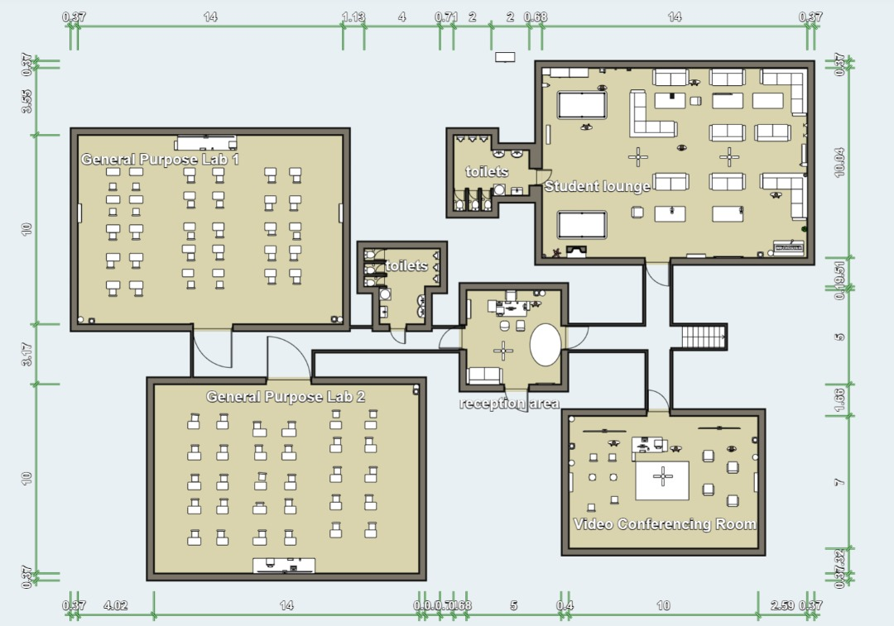

**Description:**

**Room Distribution:**

1. Student Lounge (14m x 10m): Placed near the entrance to provide easy access for students for relaxation and study.
2. General Purpose Lab 1 (14m x 10m): Positioned beside the student lounge for convenience.
3. General Purpose Lab 2 (14m x 10m): Located near the first general lab to maintain consistency in layout.
4. Video Conferencing Room (Approx. 10m x 7m): Placed near the Reception to easy access the group meetings.
5. Entrance leads to a lobby/reception area.

**Floor Layout:**

* **General Purpose Lab 1:**

1. Located on the left side of the layout.
2. Contains multiple desks arranged in rows, offers good environment for studying.
3. Wi-Fi is offered in the lab, which makes the users connected.

* **General Purpose Lab 2:**

1. Positioned directly below General Purpose Lab 1.
2. Similar in layout to Lab 1, with desks arranged in rows.
3. Wi-Fi is also offered for users as General Purpose Lab 1.

* **Student Longue:**

1. Located at the top right corner of the layout.
2. More relaxing environment, where sofas and other types of chairs are offered
3. Wi-Fi router is placed in the bottom right corner of the room.

* **Video Conferencing Room:**

1. Positioned at the bottom right of the layout.
2. The room is equipped with a central table, with chairs around it. A camera is offered for recording meetings and videos. Room offers isolation for users to record.

* **Reception:**

1. Centrally located near the entrance to the other rooms. Which makes it easy to access.
2. A table with three chairs (1 for employees 2 for guests ) and a sofa are offered.

* **Toilets**:

1. Located adjacent to the student lounge.
2. A small room with basic restroom facilities.

**Floor 2:**

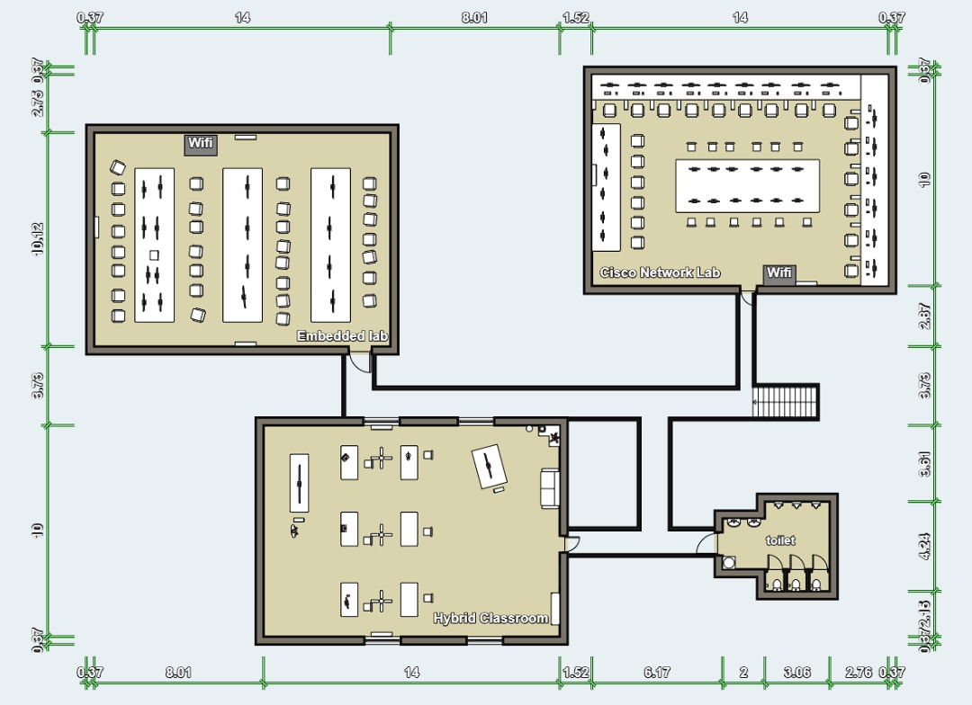

**Description:**

**Room distribution:**

1. Hybrid Classroom (14m x 10m): Positioned under the two labs with access through Cisco Network Lab and stairs.
2. Cisco Network Lab (14m x 10m): Requires a dedicated space for networking equipment.
3. Embedded Lab (14m x 10m): Requires space for IoT and sensor devices.

**Floor Layout:**

* **Embedded Lab**:

1. Located in the top left of the floor layout.
2. At the center of the lab are long benches aligned in rows facing each other. Chairs and workstations are fastened to the bench.
3. Wi-Fi is offered in the room for users to access websites and be connected to each other.

* **Cisco Network Lab:**

1. Positioned adjacent to the Embedded Lab on the right.
2. The room offers a central table with monitors and chairs for users.
3. The room is surrounded with tables adjacent to the walls. Workstations and chairs are offered for users.
4. The lab is designed for collaborative work.
5. Wi-Fi is offered in the room.

* **Hybrid Classroom**:

1. Located directly under the two labs.
2. The room offers hybrid meetings (online and f2f).
3. Tables with monitors are placed for viewers. The main monitor is tilted a little for back-view.
4. The room has 3 fans for better circulation of air.

**Estimate rubric marks for TASK 1**

|  |  |
| --- | --- |
| **Task 1** | |
| **ITEM** | **EXPECTED MARKS** |
| Group name and members | 2 |
| Suggested floor plan |  |
| Fit description – as per case study provided | 2 |
| A total 30 workstations and other equipment planned for each lab | 2 |
| Scale: with Scale | 1 |
| Clear and readable has appropriate labels | 2 |
| Creativity | .5 |
| TOTAL | 9.5 |

**MEETING MINUTES TASK 1: -**

|  |  |
| --- | --- |
| DATE | 8TH OCT 2024 9PM |
| LOCATION | STUDENT LOUNGE |
| AGENDA | FLOOR PLAN AND DESIGN |
| MEETING MC | MUNTASIR RAHAMAN SIRKHAZI |

**ATTENDANCE: -**

|  |  |
| --- | --- |
| NAME | TIME |
| Muhd Affiq Firdaus Bin Saiddi Ali Firdaus (A23MJ5083) | 4PM-9PM |
| Muntasir Rahman Sirkhazi (A23MJ0013) | 4PM-9PM |
| Mohamed G.S. Elmashharawi (A23MJ0009) | 4PM-9PM |
| Maarof Saqr Yousef  (A23MJ4006) | 4PM-9PM |
| Helal, Muhieddin Ibrahim (A23MJ4004) | 4PM-9PM |

**MINUTES: -**

|  |  |  |  |
| --- | --- | --- | --- |
| NO | ITEM DISCUSSED | IDEAS/SUGGESTION AND PERSON GIVING IT | PERSON IN CHARGE AND DATE |
| 1 | NAME | Saqr suggested (Eleven-Nine) as a Group Name | Saqr  8TH OCT |
| 2 | SOFTWARE USE | Muntasir suggested a Floor Plan Creator Set, Project Goals, and Objectives | Muntasir/Jamal  8TH OCT |
| 3 | FLOOR DESIGN | Muntasir and Affiq suggested the floor Plan/Design | Muntasir/Affiq/Helal  8TH OCT |
| 4 | MEETING ENDED | 15/10 – work was done and submitted |  |